**Unit 15: Website Development (Doc.1)**

Mohammed Mahin Ibnay Mamun / 346584

# Task 1: Comparison of real website examples

|  |  |
| --- | --- |
| P1 | Compare the principles of website design used in two websites, including their suitability for the intended audience, and intended purpose. |

1) Sky news

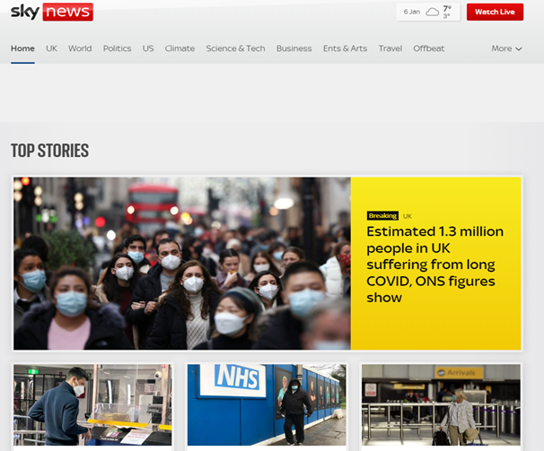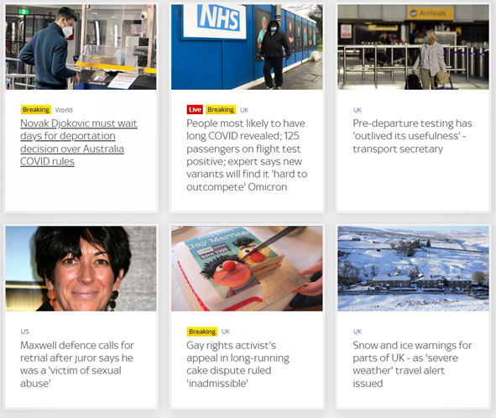

2) BBC news

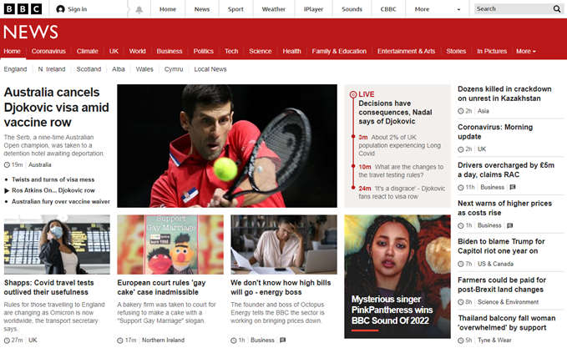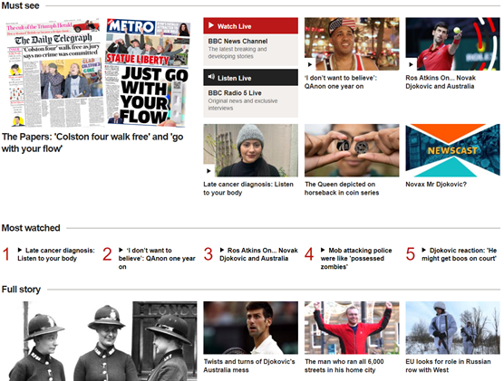

**1a – Review two websites (P1, M1, D1)**

**1) Sky NEWS**

**Target Audience**

You can define a target audience based on their common characteristics such as:

* Location
* Age
* Gender

The target audience for the sky news website can vary, depending on factors such as age, gender, or education, but users who utilize the website extensively are usually between the ages of 34-45, while broadcast news has a main target audience of 60-plus. In addition, other sky news websites have an average age between 16 and 35, suggesting Sky News has a much older demographic than the other sky news websites.

**What should the requirements be for their target audience**

Sky News is targeting an audience of 34-45-year-olds. As a result, the website should be kept professional and clear for their audience. When designing the website, they should avoid nonsensical text and low-level language as older viewers will not find it appealing.

**Key Features**

A good navigation system on your site will help your audience find what they are looking for. Media and objects are another way to direct your audience. You can provide a link to enhance your audience's research, for example, if you are writing a headline.

Also consider accessibility when you design the website, especially if you are targeting a disabled audience. Text-to-speech is an effortless way to make your website accessible.

To ensure the target audience is satisfied, a news website must be easy to use. Developers should look to maximize white space as much as possible without using it completely.

**How does the website meet their purpose**

By posting the latest news on their site, sky news fulfils their purpose, and they prevent complaints that their news is outdated. This assures their target audience that their news is always up to date.

**How successful is the website design**

There are many key components that make Sky News' website successful, such as:

* Usability
* White space
* Site layout
* Accessibility
* Navigation
* Typography
* Alignment
* Clarity
* Consistency
* Accuracy
* Content
* Simplicity

(Multiple key features are listed above, which I explain in more detail in the second document).

**How well does the website meet the needs of the audience?**

To meet the needs of their audience, Sky News ensures that their website fulfils all requirements. Here are some of the requirements:

* Up to date news
* User friendly
* Consistent
* Navigational
* Customisable
* Responsive

(Document 2 contains a much more detailed list of the key requirements).

**How have the developers tried to make the website more accessible**

An accessible website, tool, or technology is one that has been designed to make it easy for people with disabilities to access it Aswell as everyone else Aswell. It can also mean anyone can access it from anywhere around the world without being restricted

**Strengths of sky news**

* One of the world's leading media groups
* Has worldwide news
* Over 30,000 employees around the world
* $15 billion in revenue annually

**Weaknesses of sky news**

* Many competitors
* Less advertising

**Opportunity to improve sky news**

* Try to beat their competitors
* Advertise their company more

**2) BBC NEWS**

**Target audience**

You can define a target audience based on their common characteristics such as:

* Location
* Age
* Gender

In addition to age, gender, and education, it is possible to target different audiences on the BBC news website. However, people who frequently use BBC news are typically between the ages of 34-45 whereas the average broadcast audience is around 60. It is also noteworthy that the BBC news site has a significantly older demographic than most BBC websites; most BBC websites have an average age of 16-35, indicating a larger older demographic than a younger one.

**What should the requirements be for their target audience**

To appeal to this audience, BBC news should keep the website professional and easy to use, because the BBC news website is designed for older audiences, they should avoid big text and low-level language since these elements will not be appropriate.

**Key Features**

It is important that the website developers keep in mind the use of white space, which means they should maximize it to the extent possible but not use it up entirely. To ensure the target audience is satisfied, a news website must be easy to use.

You should also pay attention to the layout of the website. Accessibility is important especially if your target audience is disabled or needs assistance. Text-to-speech is an effortless way to remedy this.

There needs to be some sort of navigation on your site so your audience can easily find the news they want. Using media and objects is another way of redirecting your audience. For instance, if you are writing a headline and your audience is interested in knowing more, you can provide a link to enhance their research.

**How does the website meet their purpose**

According to BBC news, they meet their purpose by updating their news and always posting the latest news. This prevents them from receiving complaints that their news is outdated, and it keeps their target audience satisfied.

**How successful is the website design**

A key reason for the success of the BBC News website is the fact that it offers many key features.

* Usability
* White space
* Site layout
* Accessibility
* Navigation
* Typography
* Alignment
* Clarity
* Consistency
* Accuracy
* Content
* Simplicity

(In the second document, I further explain several of the key features in the list above).

**How well does the website meet the needs of the audience?**

The BBC News website ensures that all requirements are met so that they can meet their audience's needs. Here are some of the requirements:

* Up to date news
* User friendly
* Consistent
* Navigational
* Customisable
* Responsive

(Document 2 contains a much more detailed list of the key requirements).

**How have the developers tried to make the website more accessible**

Accessible websites allow anyone anywhere in the world to use it without restrictions. All people, including people with disabilities, are included in this.

**Strengths of sky news**

* The website is always up to date
* Reports on 240 countries
* World's largest broadcaster

**Weaknesses of sky news**

* There have been uproars over world issues
* Many news publications present an unbiased perspective that will not appeal to all audiences
* Biased views
* Expensive operating cost

**Opportunity to improve sky news**

* By increasing the number of correspondents and improving the analysis of events, we can cover global events more effectively
* Reporting on any story should be unbiased
* Promote your brand through global events

**Comparison of sky news vs BBC news**

Key differences:

1) sky news consists of only one navigation bar whereas BBC news has multiple.

**SKY news**



**BBC News**

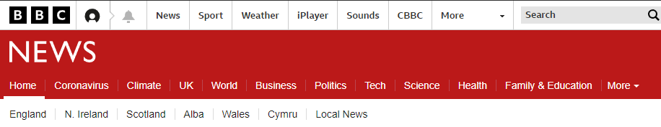

2) Moreover, BBC news shows their viewers the headline and a concise summary of the headline, unlike Sky news, which displays only the headline.

**BBC News**

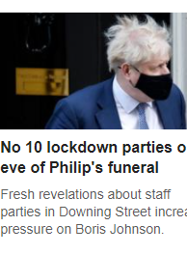

**Sky news**

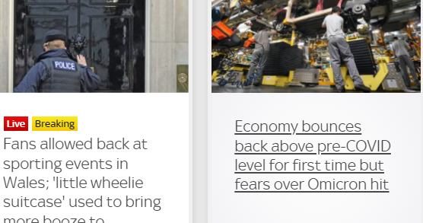

3) There is also a glaring difference in sky news showing the date and weather on their website, unlike BBC news.

**Sky news**



**Loading Time**

There is little latency between sky news and BBC news. When you are redirected from the home page to a headline, you get directly to that page in less than a second. Both websites have close delay time.

**Accessibility of the website**

Those visiting both websites can access them from any country. There are no restrictions when accessing their webpages. However, neither of these websites have the option for voice text. This is seen as a disadvantage but also an opportunity to improve for both. This will be beneficial for people with reading problems.0

**Conclusion**

The BBC news website is more successful than Sky news, largely because it is consistently up to date with news from 240 countries across the world. Research was conducted and it was concluded that BBC news is also the most trusted and reliable source of news. That is another reason BBC news is better than sky news. This proves the face that they are showing relevant content. As a news channel, BBC updates their content on a regular basis, so their success is higher.